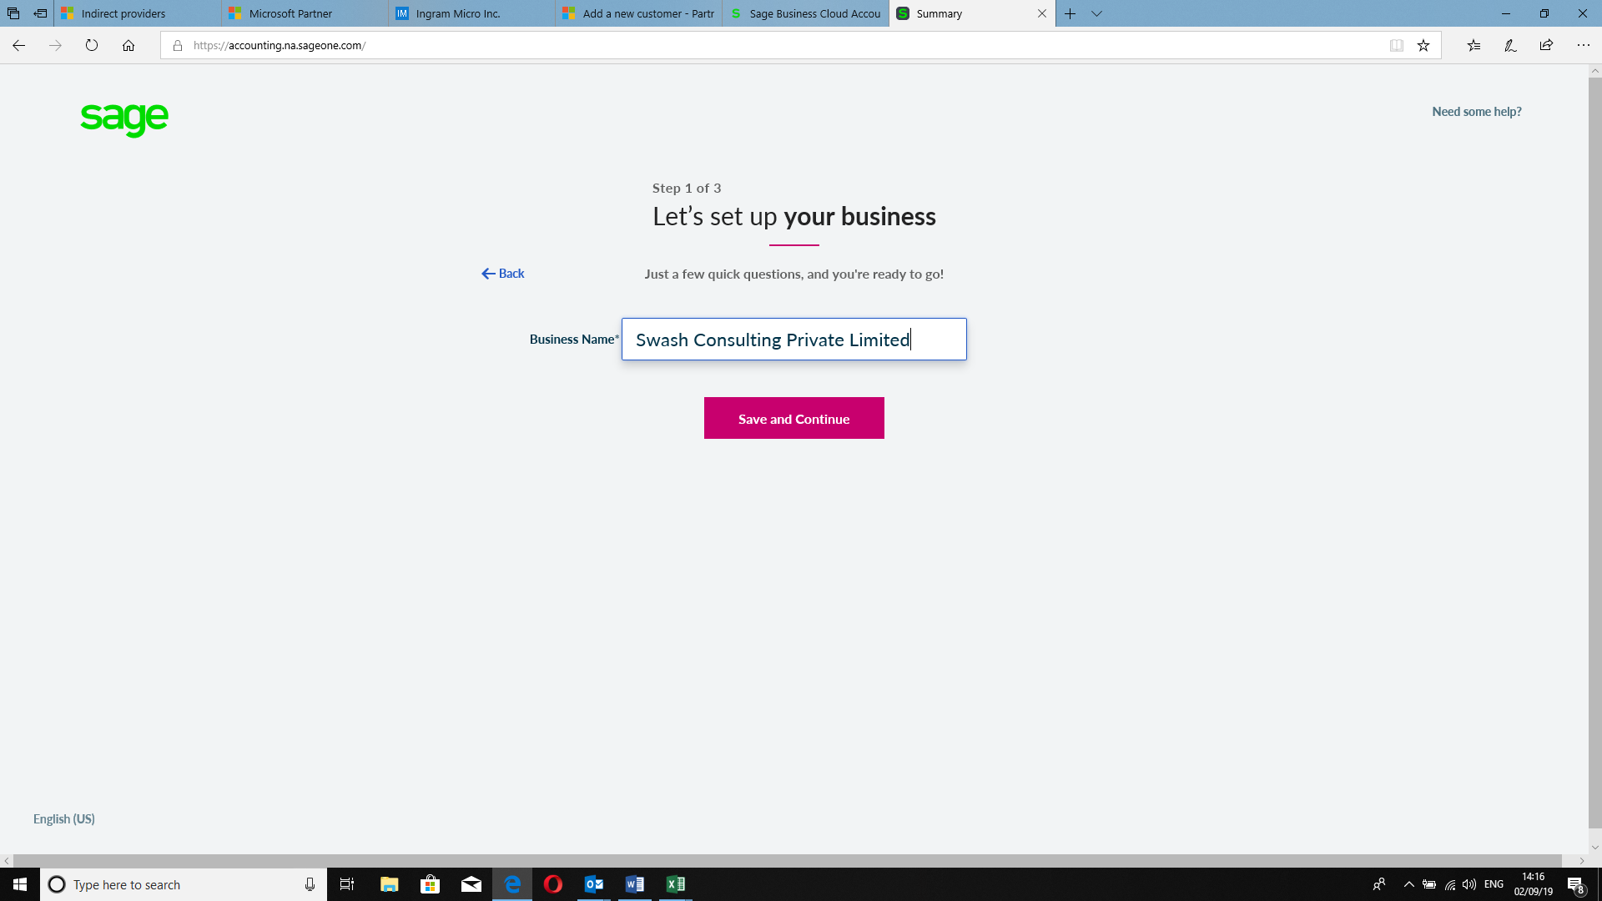

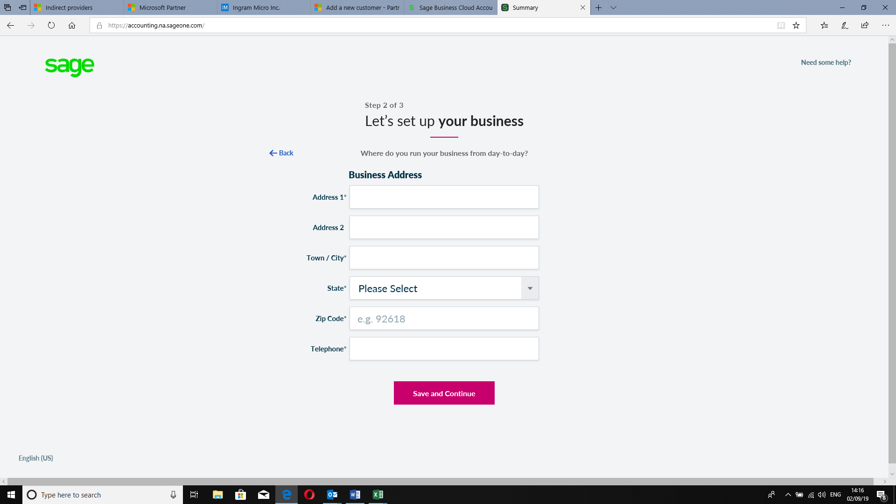

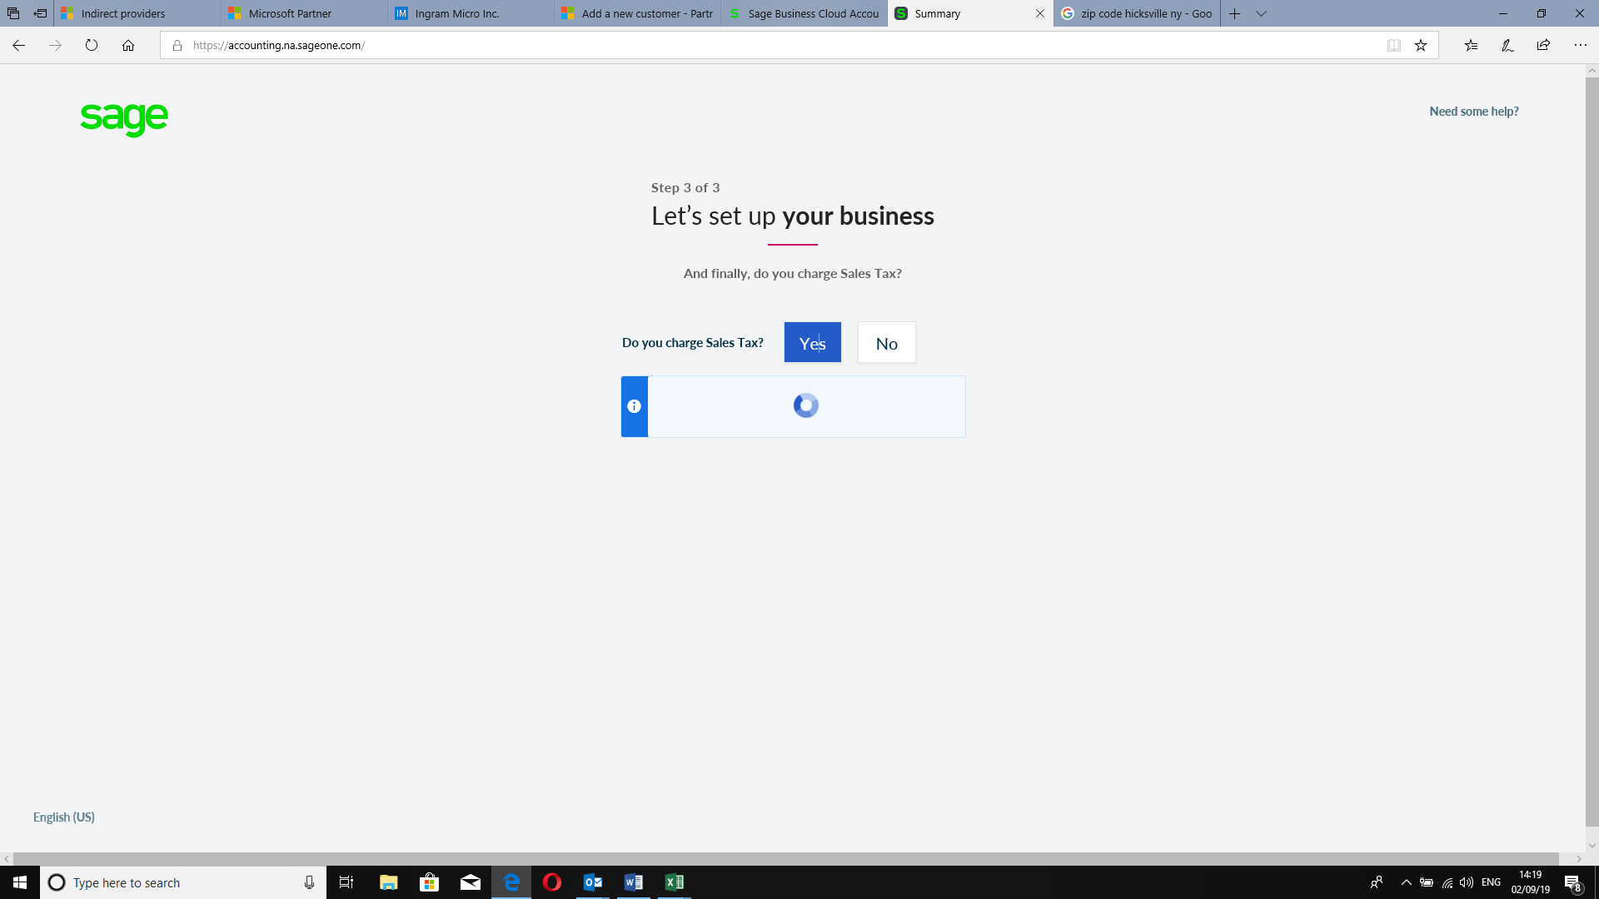

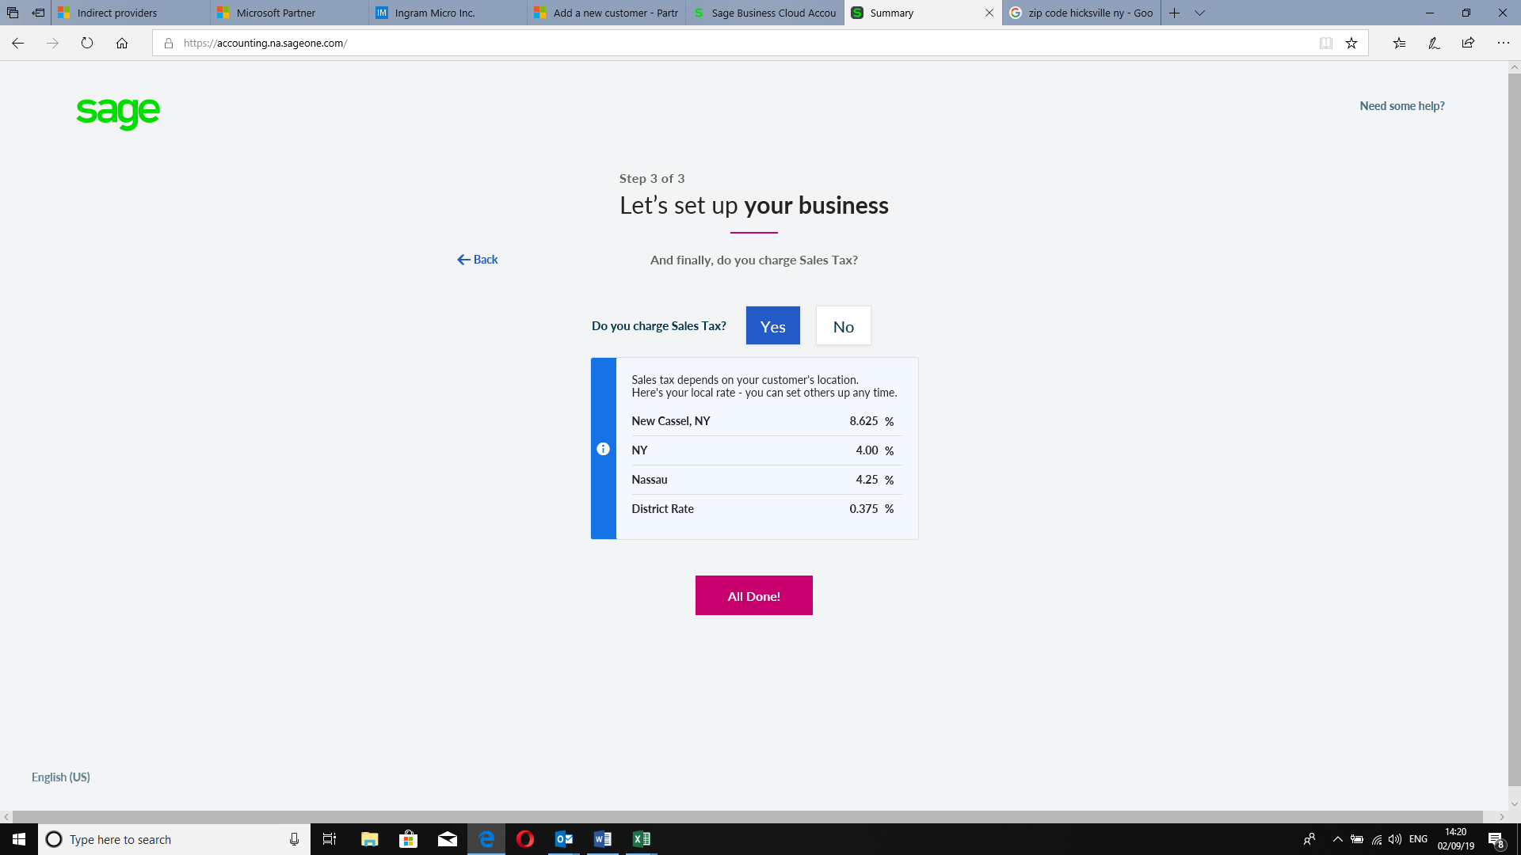

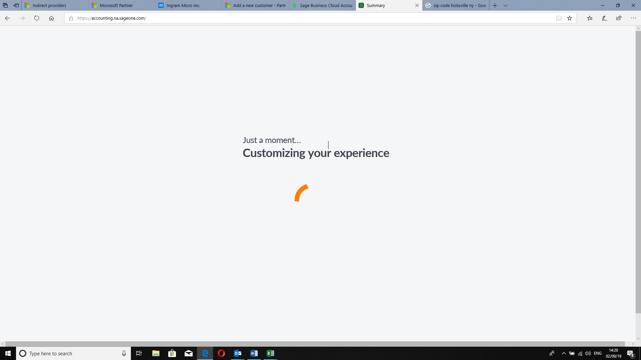

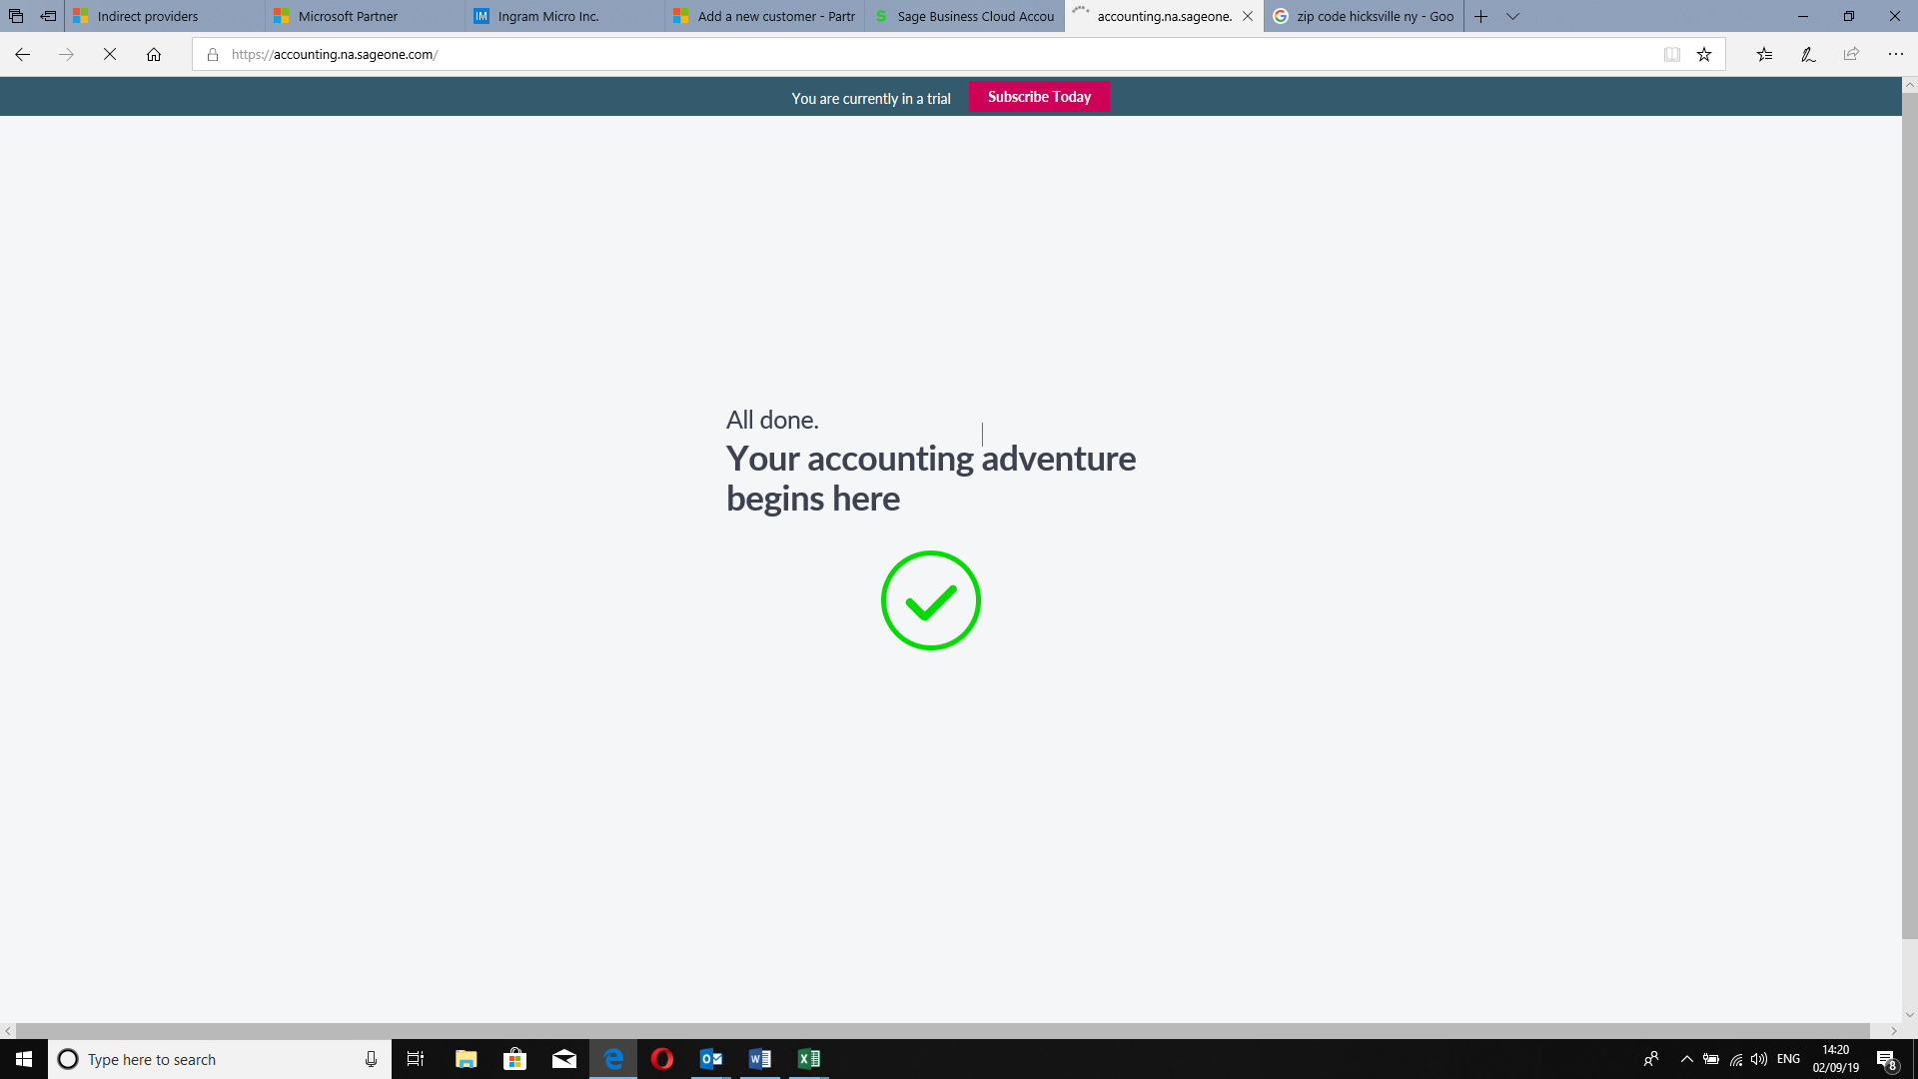

@{

Layout = null;

}

<html lang="en">

<head>

<title>KENCLOUD</title>

<link rel="shortcut icon" href="https://kencloudadmin.blob.core.windows.net/kencloudecosysadmin/faviconall.ico" />

<meta charset="utf-8">

<meta name="viewport" content="width=device-width, initial-scale=1">

<link rel="stylesheet" href="https://maxcdn.bootstrapcdn.com/bootstrap/3.3.7/css/bootstrap.min.css">

<script src="https://ajax.googleapis.com/ajax/libs/jquery/3.3.1/jquery.min.js"></script>

<script src="https://maxcdn.bootstrapcdn.com/bootstrap/3.3.7/js/bootstrap.min.js"></script>

<style>

.business_setup{

display:flex;

justify-content:center

}

.business_setup .procs_num{

}

</style>

</head>

<body>

<div class="row business_setup">

<div class="col-md-6">

<div class="row">

<span class="procs_num">

Step 1 of 3

</span>

<h4>Let's set up your business</h4>

<span class="bodr_btm"></span>

<span class="procs_num">

Just a few quick questions,and you're ready to go!

</span>

</div>

</div>

</div>

</body>

</html>

